I AM IT Iowa Website Proposal

## Craig Barkley and Bailey Borchert

# Table of Contents

1. Executive Summary
2. Project solution
3. Technologies
4. Project timeline
5. Implementation plan
6. Conclusion

# 

# Executive Summary

## Background

This proposal was developed in response to the Capstone project for the Web Technologies Program at Kirkwood Community College. The request came from Gary Vogt, to have the iamiowa.us website to be redesigned with new functionality and to additionally be able to take and respond to usage data and feedback from users about the services the site is offering. To meet these needs, my fellow collegiate and I propose a multiphase solution code named Project I*owa*T Crowd. This proposal is developed initially for the class requirements and deliverables. We will take input from stakeholders and then will seek direction from our product owner, product managers, including college/school technical educators and tutors, throughout this semester.

In addition we will be looking SEO ranking, domain name usage, and other tools and code to determine the best path forward for the site redesign. Ensuring to keep valuable site assets available while creating a new user experience that will hopefully capture new data and provide site administrators with useful data for managing future site updates. We will accomplish this through strategic analysis, discovery of current information architecture, wireframing, technical system design(code implementation to be scalable), graphic and user interface design, and then the final content creation and implementation of a live working site. Our surmised list of goals is as follows:

## Goals

* Create a functioning website to replace the current live website for the I AM IT Sector Board with a live view on github for continued reference.
* Use web design principles to improve the site aesthetics, usability, accessibility, and functionality to include a database component.
* Provide UX/UI that creates return visits and a greater click through rate that can be measured through a program like AWSTATS. Making information for the intended audience of our site more transparent and accessible.
* Increase SEO score of website, to include necessary code requirements.
* Ensure that HTML and CSS is all valid and up to date with the HTML5 and CSS3

## 

## About us

* Bailey is a Cedar Rapids, IA native who enrolled at Kirkwood Community College after graduating high school. She’s currently a full-time student in the Web Technologies program, with an emphasis in graphic design, which she will complete in fall of 2019. She also works a part-time position at Starbucks as a barista.
* Craig Barkley, has been in Cedar Rapids since 2012, working as a MIS manager for Ecolips, Inc. Since 2017, he has been enrolled full time at Kirkwood in the Web Technologies program and the Software Development program as well. In the summer of 2018 he finished a five month code school call DeltaV located in Cedar Rapids, which covers the full stack javascript implementations using React framework. He will graduate both programs from kirkwood in the fall of 2019.

## 

## About the project

This was taken on as a final project for the Associate of Applied Science degree for Web Technologies at Kirkwood. As students of Mark Bromwich, Bailey and Craig are to work as a team to design and launch a fully functional website for a client, Gary Vogt. The intent is for this website to potentially replace the existing website for the I AM IT Sector Board, which is currently live at [iamitiowa.com](http://iamitiowa.com/). Craig currently works for one of the individuals that are on the site and in the video. As such, it was nice to get a back story from one of the sites content providers. His perspective was valuable during the persona and project proposal creation.

# Project Solution

## Client needs

* More modern design than current site
* Captcha form on contact page to prevent emails from bots
* Disclosure included in footer
* Informational videos/YouTube channel incorporated into site
* Database storage for information

## 

## Client responsibilities

* Providing us with information regarding their needs
* Being available as a resource for us to ask questions

## 

## Deliverables

* Proposal document, including all information outlined in the document by Mark in Talon
* Site planning documents: user personas, site diagram, database diagram, wireframes, prototypes, and any other planning tools utilized
* Functioning website, including the code, files, and tools associated

## Personas

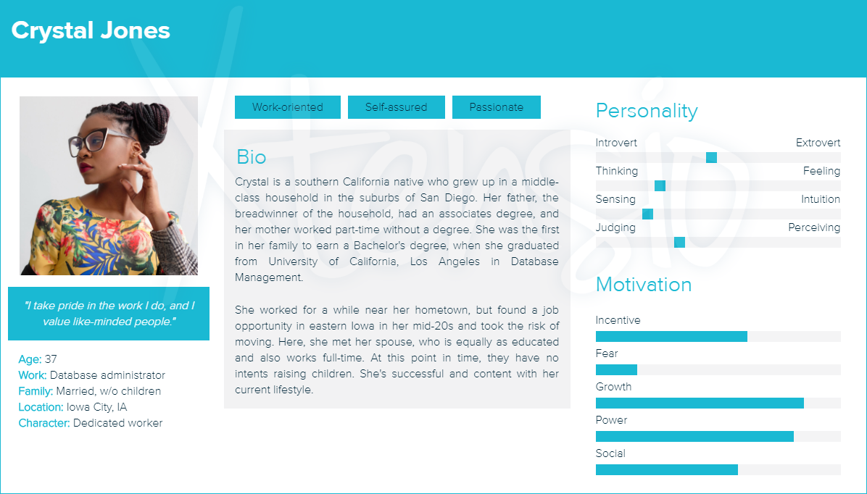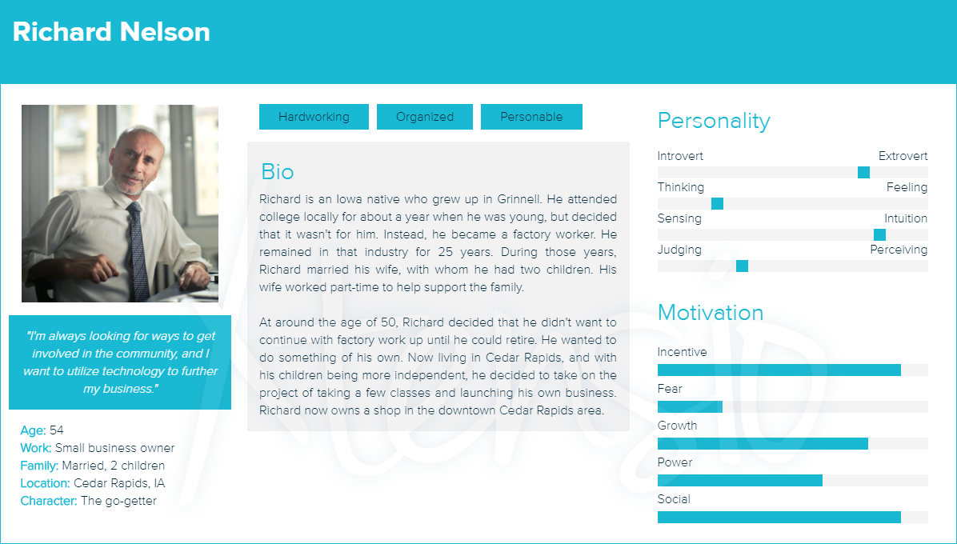

## 

## 

## 

## 

## 

## 

## Site diagram

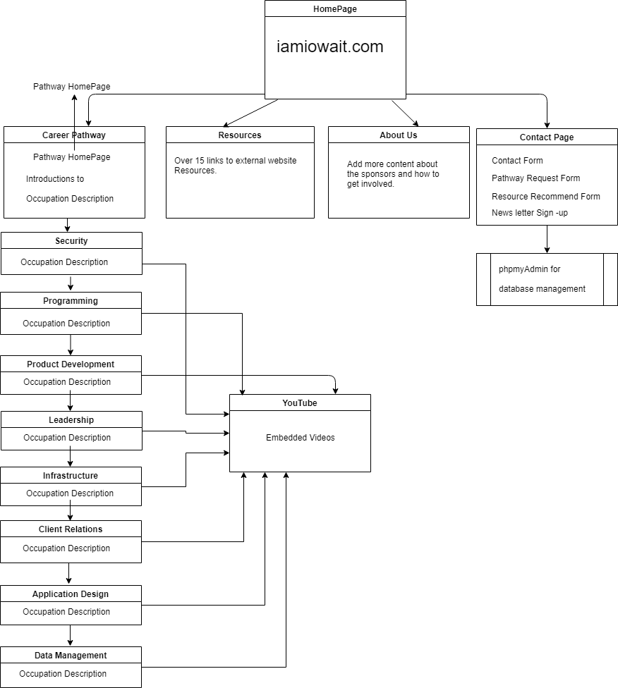

## Database diagram

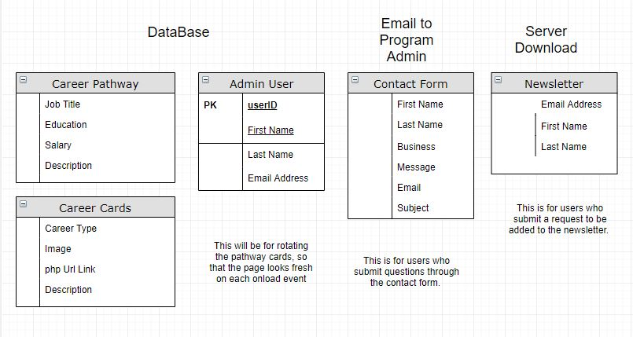

## 

## Wireframes

## 

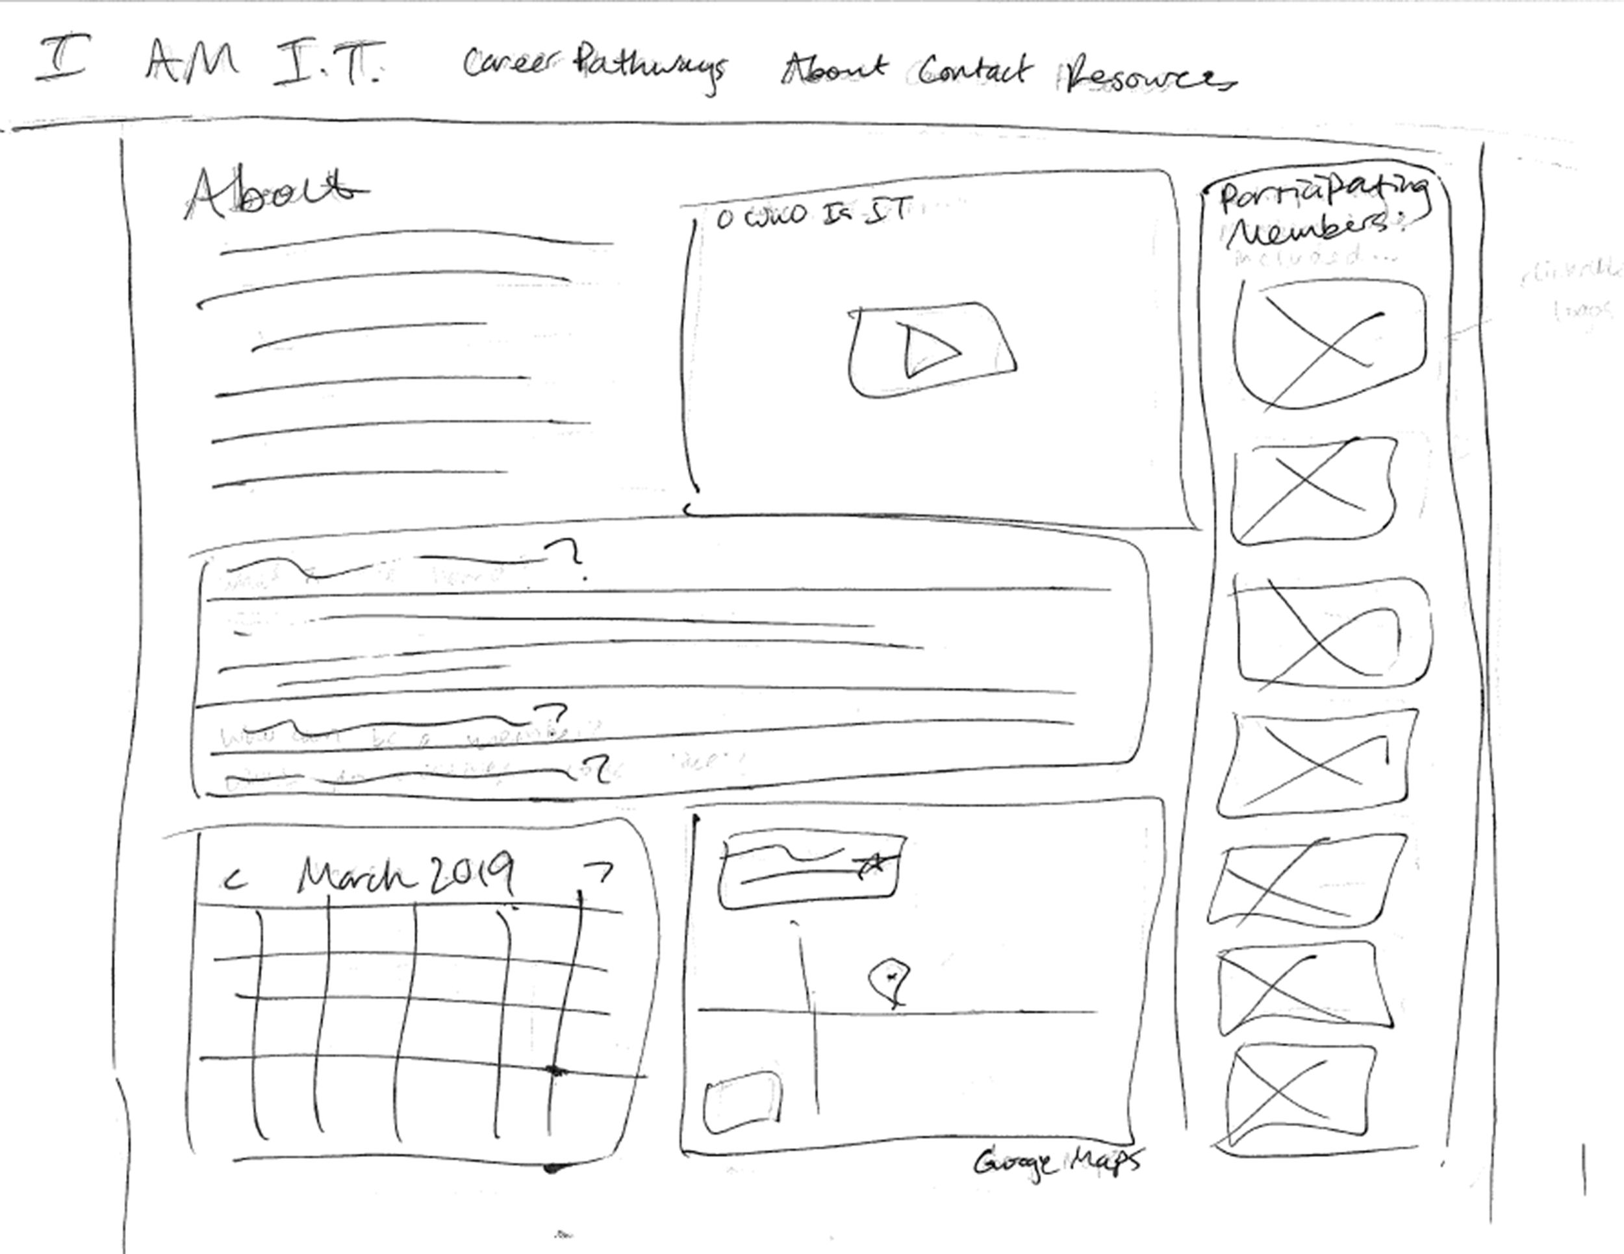

## 

# 

## Prototypes

## 

## 

## 

## 

## 

## 

## 

# Technologies

## List/application

Software -

Uniserver, The Uniform Server is a free lightweight WAMP server solution for Windows. .

<http://whois.domaintools.com/> - Domain Look up Tool. Product of Godaddy.

## Web hosting

Github - GitHub is a development platform inspired by the way you work. <https://github.com/tektechnologies/WebTechnologiesCapstone>

Tek Technologies - Domain Registrar and Internet Products retailer.

## Domain name

<http://iamitiowa.com/> - I am IT.

## Whois [Record](http://whois.domaintools.com/iamitiowa.com) for IaMitIowa.com

#### Domain Profile

|  |  |
| --- | --- |
| **Registrant Country** | US |
| **Registrar** | GoDaddy.com, LLC  IANA ID: 146  URL: http://www.godaddy.com  Whois Server: whois.godaddy.com |
| **Dates** | 873 days old Created on 2016-09-07 Expires on 2019-09-07 Updated on 2017-09-05 |
| **Domain Status** | Registered And Active Website |
| **IP History** | 4 changes on 4 unique IP addresses over 3 years |
| **Registrar History** | 1 registrar |
| **Hosting History** | 1 change on 2 unique name servers over 3 years |

#### 

#### Website

|  |  |
| --- | --- |
| **SEO Score** | 87% |
| **Terms** | 250 (Unique: 150, Linked: 43) |
| **Images** | 9 (**Alt tags missing: 8**) |
| **Links** | (**Internal: 18, Outbound: 2**) |

.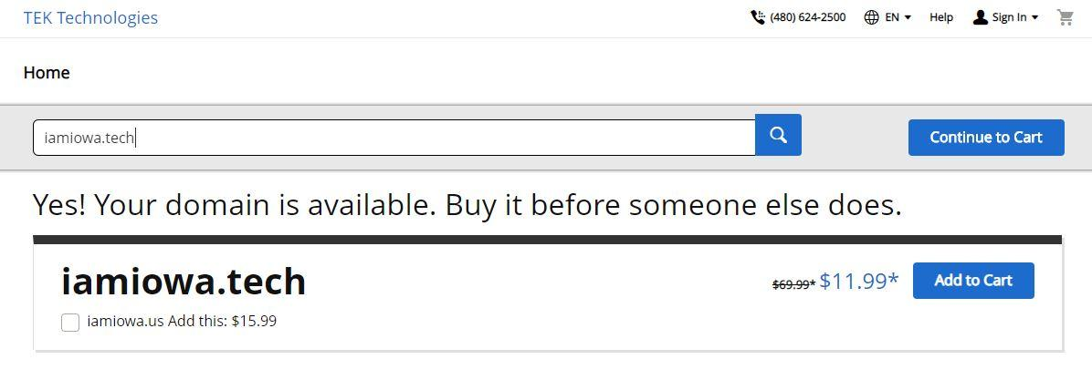

Possible update to the domain name would make it easier for user to remember, by way of keywords, it is shorter in length, more unique and reduces doubled letters. These are all improvements over the current domain name. This domain name is most likely more expensive than your current .com hosted with godaddy.

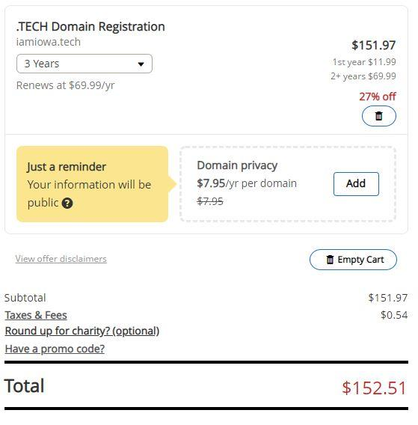

# Project Timeline

## Gantt chart We created a Gantt Chart that spanned the length of the semester. Starting with the semester start and then on to the Project Proposal with a detailed breakdown of each of its internal components. Next, we added tasks that will include the actual site planning and design of strategies and content. Lastly, we added the build phases. Mainly four sprints that last from 11-18 days. The choice for the longer sprints is to compensate for only having two developers on the team. There is some time in the schedule for backlog items to get completed in the event that we miss a sprint deadline.

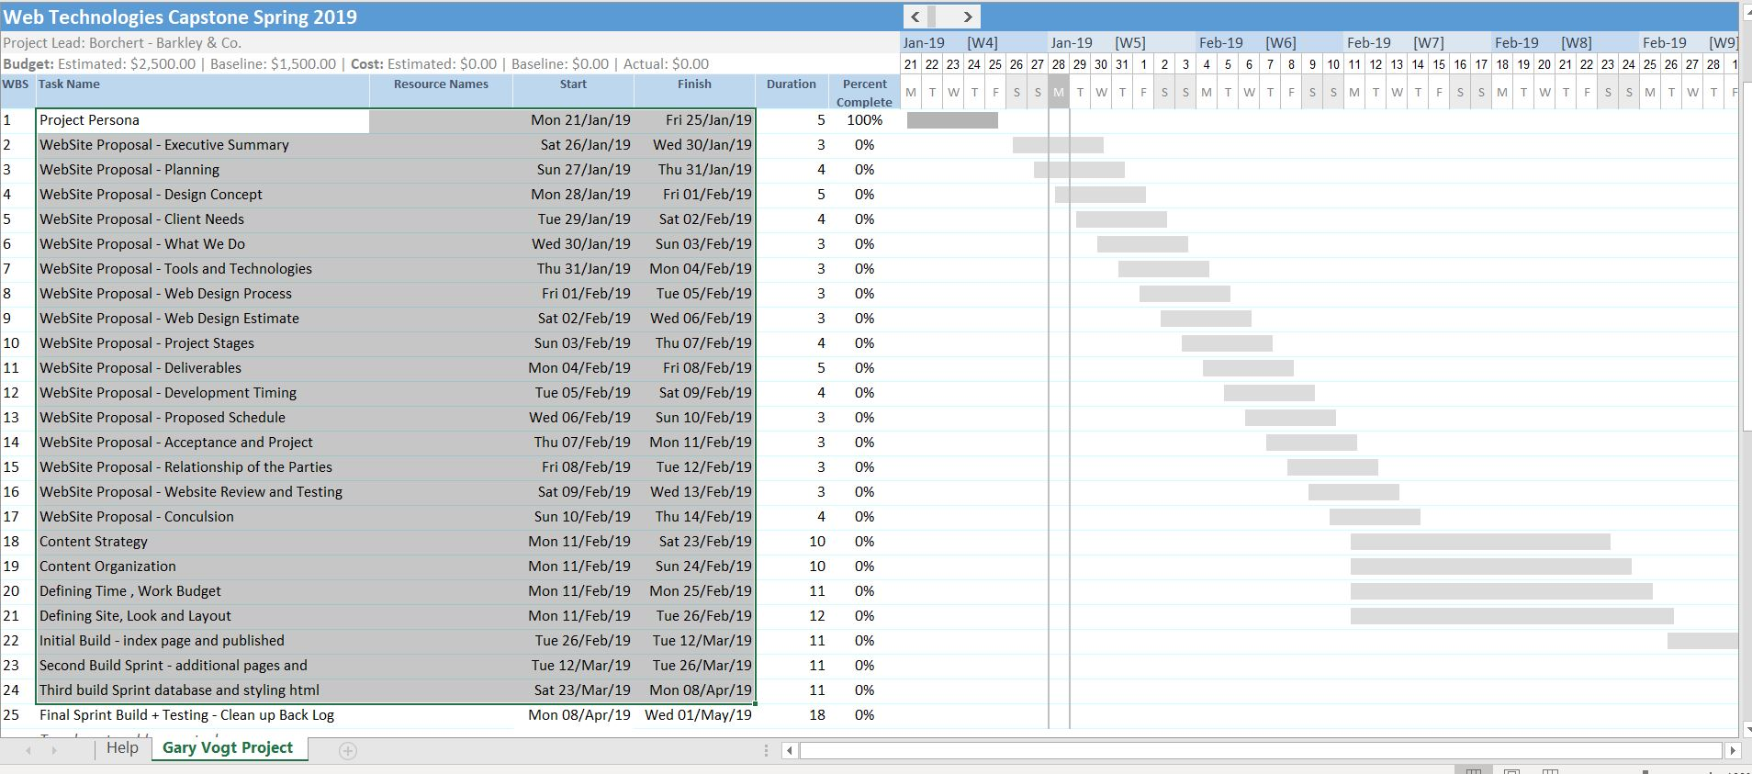

## Schedule

* Project must be fully completed and ready to present to the client by 9:05 AM on Wednesday, May 8, 2019.

# Workflow

## **Preparation phase: Managing client expectations** While maintaining an existing website or designing a new website from scratch, both the project developers and our client are required to manage each other’s expectations. While our primary responsibility is to understand the requirement of the project in detail, the client’s responsibility is to understand how each choice that is made impacts the scope and the budget of the project, through our initial meetings and retros**.**We will let our client know about the required technology, the required budget, and the time frame required for finishing the project. Approaching our project in an organized manner will enable us to complete semester requirements on time. **Phase 1: Defining site goals**

## Set up the overall structure, decide on content and assign roles and the different deliverables throughout the project. Proper planning right from the start, will save us from inefficiencies common in most web site design projects. We will work with the client and teacher to establish the schedule, timeline, technical needs, visual style and the content structure for the targeted audience. TRELLO**,** is a well-known and easy-to-use project management tools. We have created various boards for our current project. With Trello we can get a quick overview of currents tasks and our backlog of work to be done. **Phase 2: Developing site structure & getting your hands dirty**

## Our site structure forms the basis of the website. It is our reference guide for us to use during the entire duration of the project. The flowcharts and site diagram show the flow of the structure. Our sitemap shows how the content is organized.We have a working xml copy to keep updating the sitemap after each revision. Wireframe**:** The wireframe will help us with aligning the content of the site to be fixed before the design and graphics are put into place and the coding begins. Our wireframes are both low-fidelity sketches of the website and show content placeholders establishing the page elements with content. We will use BALSAMIQ**,** is a graphical wireframing tool that we can use to rough out the site look and feel using predefined tools, that will off a better vision of the sites actual look and feel. **Phase 3: Developing the site & working with client**

Now it's time to send the mockups to the client for approval. The client submits any change requests, changes are made, and when the mockups are finalized, it's time to convert them into web pages. Now it is time to code up the site, basically recreate the graphical mockups in HTML form. There's no logic programmed at this point. Next is to build out the application logic or database functionality. Next is to test and launch the site on an actual server. Once we have a functioning site we can continue to test the sites pages. After presentation if the client is so inclined we would take down the other site and upload the new one. Lastly, we would have the client approve and sign off on the completion of the site design, build and launch.

# Implementation Plan

## Testing/debugging

* Database debugging
* Testing input validation for contact form and search form
* Testing search form for pulling correct info
* Browser support

## Future upgrades/updates

* Admin back-end for content updates or additions
* Scaling application for another platform - C#, JavaScript React Framework
* Creating a single-page app for mobile development, mobile-first
* Keeping a developer on commission to be able to update site
* Additional security for database
* More advanced SEO - rather than just putting in meta tags, list URL in Google Developer Tools to get bots to index the site for SEO

# Conclusion

Our version of the website is more aesthetically pleasing with more dynamic CSS styling.

We used a site diagram to structure the navigation in more a more user-friendly way.

We added new functionalities, such as the search function, automated pages, and an admin side that can be logged into.

We implemented a database to organize information and allow for it to be easily updated.

We added a more detailed contact form, which now includes a business/organization field and a subject field. Although not included in our demo site, we’ve also included space for a captcha field to be implemented if the site were to be used live.

Thank you for taking the time to look at our site project! We hope you consider implementing this as the new I Am IT website.